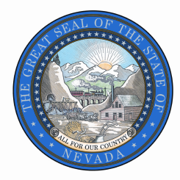
STATE OF NEVADA, OFFICE OF THE CIO
Public Records Request
Mail, Fax, or Email to:
100 N. Stewart St., Ste. 100, Carson City NV 89701
Fax: (775) 684-9097 | CIO@it.nv.gov

Date of Request
Requestor Contact Information
Name:
Organization:
Address:
City, State, Zip:
Phone:
E-mail:

Records Requested:
Check one: Paper copies Electronic copies Certified copies Inspection (in person)
Please be specific and include as much detail as possible regarding the records you are requesting.

To complete an estimate, the agency will need the following information:
I will pick up | Please FedEx  Fed Ex billing number: | Please send USPS | E-mail (if format allows)

Statement
I understand there may be a charge for copies of public records. I understand I will receive a written estimate for production of the records indicated above if the estimated cost is expected to be over $25.00, which I will be required to pay in full prior to inspection or reproduction. Materials will be held for 30 days.
Requester  Signature | ^{Signature}

Office Use Only
Request status: |  | Estimate:
_{Date}  __________________ | Request received | Estimate: | $ _____________________
__________________ | Receipt acknowledgement issued | Date deposit received | __________________
__________________ | Request filled | Actual (if different): | $ _____________________
__________________ | Estimated completion | Date final payment received | __________________
__________________ | Estimate provided | Completed by | __________________
__________________ | Request denied in whole
__________________ | Other: | Retain request form for three (3) calendar years from the end of the calendar year in which the response was completed according to RDA 2015013

